The New Meaning of Housing in America

Abstract: A generation ago, financial innovation promised a future of post-materialist housing markets freed of the old limits of geographical and institutional scarcity. Yet deregulation and competitive financial innovation were shaped by America’s enduring racial state, which created new inequalities in the unprecedented wave of deregulated speculation in American mortgage debt. In this paper, we map the dangerous new spatial configurations of law and racial exploitation that connect local housing markets to national and transnational circuits of capital.

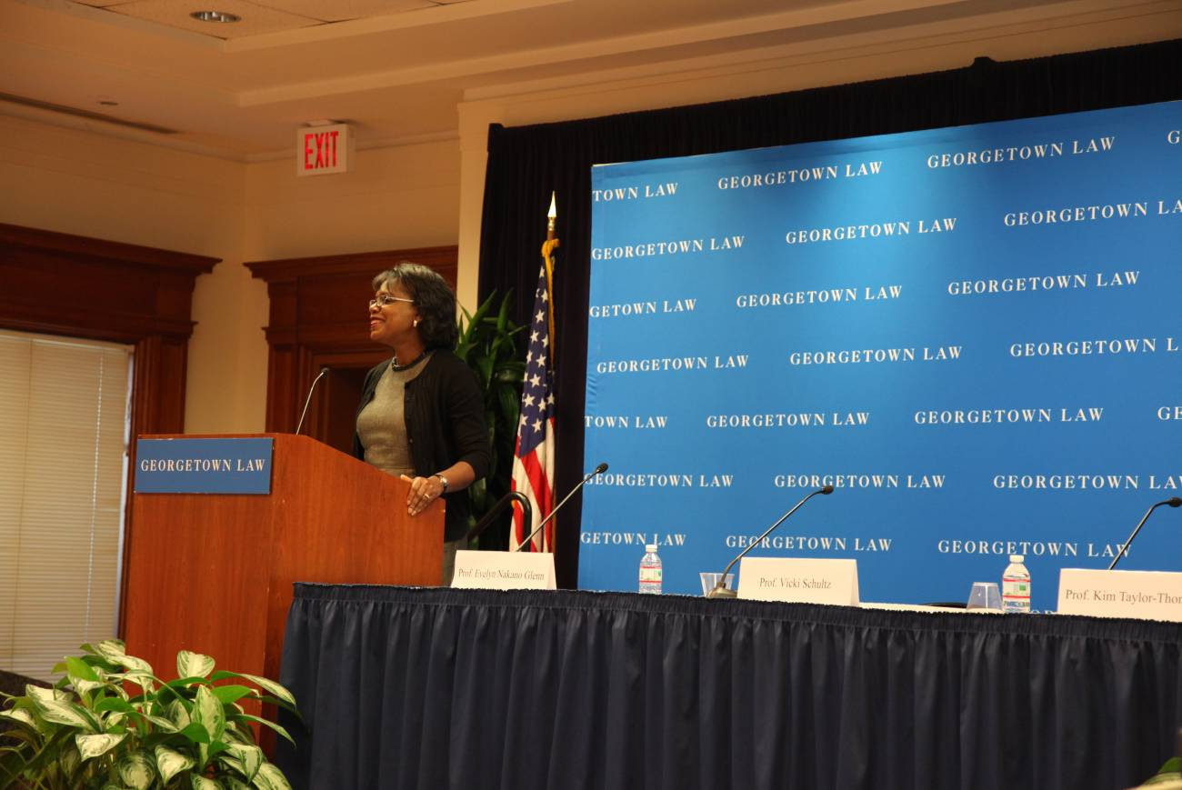
Fig. 1. Professor Anita Hill, October 2011 (author)

“In the twilight of materialism, the meaning of housing will be simplified and clarified, with a renewed emphasis on shelter and neighborhood. The false hope that everyone can get rich from real estate will be laid to rest for another fifty years, or perhaps for all time.”
John S. Adams (1986, p. 234)
“Equality begins at home.”
Anita F. Hill (1995, p. 288)

October, 2011 marked the twenty-year anniversary of the televised U.S. Senate confirmation hearings for Clarence Thomas, whose nomination to the Supreme Court had been complicated by allegations of sexual harassment. The proceedings became “the most riveting television” (Smith, 1995) when the Senate leadership reluctantly allowed testimony from Anita F. Hill, who worked with Thomas at the Equal Employment Opportunity Commission in a hostile climate of repeated sexual harassment. Thomas, a prominent African-American conservative Republican, “was able to swing the hearings in his favor...when he played the most powerful card in his deck: the specter of lynching” (Malveaux, 1995, p. xiii). Thomas famously attacked the proceedings as “a high-tech lynching for uppity blacks who in any way deign to think for themselves” (Hill and Jordan, 1995, p. xxvi).
The riveting coverage showcased a pivotal moment in America’s racial state (Omi and Winant, 1994; Goldberg, 2002). A resurgent American Right was achieving notable success in attacking the explicit racial-equality legacies of the Civil Rights era. Conservatives were energized by the prospect of the hard-right Thomas replacing Thurgood Marshall, the lawyer who argued Brown vs. Board of Education before becoming the first African-American to serve on the high court. Thomas attacked the race-based civil rights organizations for “wallowing in self-delusion,” (Thomas, 1985, p. 35), and tore into Marshall’s defense of the “evolutionary constitution” as an “assault on the Bicentennial, the Founding, and the Constitution itself” (Thomas, 1987, p. B7). At the Hill-Thomas hearings, egregious procedural errors (Ogletree, 1995) and vicious attacks on Hill also achieved other goals, including fostering a disrespect for the entire process, and demonstrating a new tactical possibility for the Right’s long march against a (mildly) progressive judiciary.
In an America divided by culture wars and the rise of individual-level identity politics, such tactics demonstrated how conservatives could individualize and fracture the broad coalition politics that had sustained Roosevelt’s New Deal and LBJ’s Great Society. The Right learned the power of identity politics as a divide-and-conquer strategy -- and the power of real-time spectacle management -- at precisely the same moment that conservatives saw the first major policy payoffs from the Chicago-School infrastructure of neoliberal economic ideology (Peck, 2010). The wholesale side of market fundamentalism had obscure but powerful networks of ideology, law, and influence designed to advance the class project of restoring a pre-welfare state mode of accumulation (Harvey, 2005). Now, movement conservatives -- as well as the power brokers pushing for “New Democrat” transformations of that party’s history of race- and class-based constituencies -- realized that market fundamentalism also needed a refurbished retail display. The old conservative attempts to justify race-class-gender alignments of exclusion from capital and debt were downplayed in favor of a new, sunny language of inclusion, opportunity, and universal access to the wonders of the market. A strengthened bipartisan emphasis on inclusion and access found its clearest expression in housing -- and particularly the owned home financed by a long-term mortgage that had come to define the American Dream (Wright, 1981; Higginbotham, 1991, pp. 1022-1025). In the 1990s and the 2000s, America’s racial state underwent significant transformation. Deeply entrenched racial disparities that were once debated in the candid, explicit language of discrimination and bigotry were now invariably portrayed in terms of consumer choice, market innovation, and personal responsibility. Market fundamentalism, and a racial state whitewashed by economic theory, allowed conservatives to blame the subprime collapse and the global crisis on minority borrowers as well as government laws that grew out of the civil rights movement.
This was the climate for Context and Consequences: The Hill-Thomas Hearings Twenty Years Later. The conference opened with a bittersweet mixture of historical reflection and forward-looking optimism. Speakers and panelists lamented the passing of the critical race theorist Derrick Bell the night before the conference began, but the discussions also offered hope for new visions of gender and racial equality. In her most recent book, Professor Hill (2011, p. 167) offered guarded optimism for what lie ahead:
“Today I am privileged to witness the coming of age of a generation that seeks to move beyond historic race and gender divisions. For them, the American Dream means nothing if it is not inclusive. Because of the financial crisis, and because of their having grown up in an era of less strident racial discrimination and in homes where women are breadwinners, they will be less willing and able to pay a premium to live in a racially-isolated (predominantly white) community.”

Hill’s analysis suggests that we need new strategies to challenge the inequalities of American racial formation (Omi and Winant, 1994) in ways that recognize demography:
“Individuals born of the passage of civil rights laws have never lived without legal protections against race and gender discrimination. For them, the rights discussion is abstraction. If we are to engage them in a struggle for progress, we must find a new way to talk about equality. ... For them, rights are a starting point, Equality 1.0. They are ready for the 4G version of equality. Before long they will no doubt be clamoring for the 10G version.” (Hill, 2011, p. 167).

Hill makes a compelling case that the values and practices of community and home can be at the heart of a transformed legal and social policy landscape for greater equality in America. We are inspired by this vision. Yet we cannot forget how the public treatment of Anita Hill in 1991 foreshadowed the callous disregard of the experiences of millions of African-American and Latina/Latino women and men in the massive expansion of predatory capitalism that culminated in the global financial crisis. The targeted discrimination and sophisticated deception used to push a disproportionate share of racially marginalized consumers into risky subprime credit was repeatedly dismissed as “anecdotal.” Detailed stories of discriminatory targeting and abusive financial practices were waved aside as isolated, singular problems that had nothing to do with the structures or laws governing housing finance. The trope of the anecdote has for too long protected the unequal structures of American neoliberalism, particularly in the realm of owner-occupied housing. In this paper, our purpose is to establish the connection between individual experiences of discrimination and the wider structures of America’s racial state. One of the papers presented at the conference, for instance, began with journalists’ accounts of the predatory abuse of several individual African-American women, and then drew on quantitative data to demonstrate the systemic extent of these kinds of abuses: across America’s metropolitan areas, single African-American women were almost five times more likely to wind up with high-risk subprime credit compared to traditional, White male-female couples -- even after accounting for income, loan amount, and other underwriting criteria (Wyly and Ponder, 2011).


Fig. 2. “We the Corporations...” Occupy DC, October 2011 (author). In the housing bubble, African-American homeowners and homebuyers in the Washington metropolitan area were 2.4 times more likely to get high-risk subprime credit compared with Whites in similar financial circumstances; for Latinas and Latinos, the disparity was 3.3.

In this paper, we map these kinds of inequalities across the American housing landscape in order to identify regional and local barriers and opportunities in the struggle for equality (Hill, 2011). While there is now a rich literature on the boom and the collapse (Immergluck, 2009; Tett, 2009; Sorkin, 2009; FCIC, 2011; Relman, 2010; Engel and McCoy, 2011), many of the spatial inequalities of American housing finance remain unexplored. Space, as it turns out, was crucial in the transformation of America’s discriminatory racial state. The rest of the paper is structured as follows. In the next section, we review a stream of housing research from a previous generation that helps us view the current crisis in a new light. Then we outline the main trends in financialization, public policy, and the law that altered the spatial constitution of housing finance. Next we describe a valuable set of data that allow us to document these patterns in new ways. Then we narrate a set of measures and maps that highlight the dynamic and contingent relations among consumers, firms, institutions, and regulatory spaces of law. In the final section we offer a few concluding remarks on the implications of our analysis.


Fig 3. Las Vegas, December 2008 (author). Between 2004 and 2006, Wall Street and local lenders funneled more than $20 billion in high-risk, high-cost subprime mortgage credit to consumers in the Las Vegas area. Compared to otherwise similar non-Hispanic Whites, African-American and Latina/o borrowers in Vegas were twice as likely to be pushed into subprime credit.

Post-Materialist Housing?
A generation ago, John S. Adams began an ambitious research agenda analyzing the transformation of housing in the United States. In his Presidential Address to the Association of American Geographers, Adams (1984, p. 515) reflected on “The Meaning of Housing in America,” and the way “housing decisions” make “...social and cultural categories of urban society visible, intelligible, and stable.” Yet the intelligible and stable patterns were in flux. Turbulent restructuring intensified housing as a site where social change collides with the deep-seated need for stability and security -- especially financial security. In “Housing Markets in the Twilight of Materialism,” Adams (1986) suggested that postindustrialism was erasing the old problems of scarcity, and reducing the opportunities to profit from the scarce resources of geographical or informational advantage. In the postindustrial global information society, the most crucial “terms of power and participation take on non-material forms.” Housing seemed ready to lead America towards something post-materialist, through a partial de-commodification of one part of the social economy.
Adams’s prediction of a post-materialist society looks a bit naive -- utopian, even -- when viewed from the far side of two dramatic housing booms, each more extravagant and dangerous than the last. It was only possible for Adams and other analysts to imagine a “post-shelter society,” where the idea of “housing as investment as well as shelter,” would “not return” (Hughes and Sternlieb, 1987, p. 15) because nobody imagined how the intense recession of the early 1980s would lead the Right to mount a steady assault on the entire infrastructure of the New Deal (Harloe, 1987, p. 7). Yet this is exactly what happened. “The fix was in,” Harvey (2011, p. 229) warns; “This was the New Deal for neoliberalism: The New Deal for Wall Street.” The attacks on regulation would eventually make housing-related debt a large part of the financial sector’s astonishing 41% share of total U.S. corporate profits on the eve of the crash. Thanks to America’s strange hybrid of entrepreneurial innovation, media dominance, and aggressive geostrategic diplomacy in economic policy, many countries around the world followed America’s lead, creating massive transnational property boom. Once again, in yet another century, a shaken world looked to Wall Street and saw in Lehman Brothers’ collapse “the worst financial crisis in global history, including the Great Depression” (Ben Bernanke, quoted in FCIC, 2011, p. 354).
Adams’s vision of the twilight of materialism presents an invitation to reconsider the housing boom in light of a global crisis that has shaken the foundations of American exceptionalism. What does housing now mean in America and about America? To focus this story, we examine one crucial empirical intersection -- the markets, institutions, and laws governing the risky and racially-stratified “subprime” sector of housing finance -- in relation to the ideas of post-materialist geography outlined by Adams (1984, 1986) and several of his contemporaries (Sternlieb and Hughes, 1980, 1987; Bell, 1973). This literature anticipated a wide range of contemporary debates over the spatial expression of social and economic change (Castells, 2010; Friedman, 2007; Hall, 2003; Smith, 2001), as well as Sassen’s (2009, p. 411) analysis of the “global circulation of mortgages” as “local housing becomes an electronic instrument.”
This is where utopias of social process collide with (white) America’s utopias of spatial form (Harvey, 2000), where the spatial segregation of the metropolis keeps the “once-marginalized” populations at a safe distance to ensure the health of white property values in a racist society. Some of the old-fashioned materialist concepts of place and geography, we contend, still matter even amidst a twilight materialism of local housing financed by globally-traded electronic mortgage instruments. Locality matters, especially at the site of innovation that was so crucial in the crisis -- the frontier between traditional, closely regulated “prime” credit governed by white privilege and scarcity (Stiglitz and Weiss, 1981) and newer forms of high-risk, deeply-racialized “subprime” credit driven by supply-side competition to maximize volume and velocity (Aalbers, 2008; Ashton, 2009; Immergluck, 2009; Crump et al., 2008). This frontier captures the essence of American structures and identities of capital, race/ethnicity, and law. And on the frontier, post-materialist processes do not dictate post-materialist geographies. Postmaterialist processes arise from, engage with, and help to reproduce localized material spaces and places. The global circulation of de-territorialized housing and finance instruments has reconfigured many of the local and metropolitan dynamics central to our understandings of housing and home (Listokin and Casey, 1980; Squires, 1992, 2003; Immergluck, 2009). But place-based inequalities persist. What has changed is that local inequalities are now more dependent on the strategies of actors in interconnected commodity-chains of local brokers, regional and national mortgage lenders, Wall Street investment houses, and transnational investors.


Fig 4. The Root Canal of Community Development. Cleveland, July 2010 (author). Cleveland was once an American icon, famous for making things. Then it became famous for deindustrialization, environmental catastrophe, and depopulation. Then came the predatory lending boom. More than $5 billion in subprime loans were made in the Cleveland metropolitan area at the height of the boom; these high-cost loans were about five times more likely to be sold to Wall Street and other private investors than conventional prime loans. Now the ongoing foreclosure crisis is making Cleveland famous yet again, this time for tearing down houses. Cleveland has about 15,000 vacant and abandoned homes, and dealing with them is described by the county land bank president as “the root canal of community development.” (Dennis, 2011, p. A1).

New Laws of Spatial Organization
It is now widely recognized that the stable, locally-oriented “golden age” of American housing and banking disappeared some time ago. Gone is the tightly-regulated regime dominated by savings and loans connecting local borrowers and savers, reliant on the standard, 30-year self-amortizing mortgage held on the lender’s books; we now have something much more spatially complex, dynamic, and risky. But how did we get here? There are two main approaches to this question. The first is an economic narrative from political economy, and addresses the transformation of housing from an older arrangement in which it was primarily a consumption good, demand for which was derived from the fundamentals of an industrial economy, to a newer postindustrial sector with its own partially autonomous dynamics of production, consumption, and speculation. Lefebvre first hypothesized a switching process, in which declining profit rates in the primary circuit of capital accumulation gradually encouraged an increase in investment and then speculation in a secondary circuit of real estate. This idea inspired a central part of Harvey’s analysis of urbanism and the connections between local, urban forms of exploitation and higher-level processes of capital accumulation and financial speculation (Harvey, 1973, pp. 312-314; Harvey, 1978, 1985). Harvey’s work in turn encouraged generations of researchers to analyze various kinds of real estate trends to test the theory (e.g., King, 1989; Beauregard, 1994; Gotham, 2009). Ironically, the mixed results of these tests reflect data limitations that also blinded the neoclassical economists in charge of public policy -- making it impossible, for instance, to measure how mortgage-backed securities were interwoven with a giant, unregulated, and undisclosed global market of trillions of dollars of credit default swaps. As the financial crisis swept the globe from the spring of 2007 into the fall of 2008, the daily headlines appeared as summaries of Lefebvre and Harvey: Marxist analyses of accumulation and financialization eerily echoed in widespread discussions of Bernanke’s (2005) suggestion of a “global savings glut” flooding into U.S. financial instruments, and Greenspan’s (2007) attempt to minimize the scale of the exploding subprime crisis by reassuring investors that “arbitrageable long-term assets are worth close to a hundred trillion dollars.” Harvey’s analyses of fictitious capital seemed almost mainstream by the time central bankers from around the world applauded the Federal Reserve’s success at the annual conference in Jackson Hole, Wyoming, in August, 2009: “...economists say Mr. Bernanke’s most important accomplishment was to create staggering amounts of money out of thin air.” (Andrews, 2009, p. A1). All that is solid melts into TARP.

New Spaces of Law
A second approach to the question of America’s new housing finance system comes from the subfield of legal geographies (see Blomley et al., 2001), and one of its antecedents, the politics of scale (Cox, 1998). Recent years have seen a revolution in thinking on the concepts of space, distance, region, and scale (cf. Schlemper, 2004; Sheppard and McMaster, 2004). Geographers, and scholars in other fields inspired by Lefebvre (1991) and the broader “spatial turn” in critical social theory, challenged the conventional view of space in terms of Cartesian coordinates that correspond (with increasing technological precision) to physical locations on the Earth’s surface (Krugman, 1998; Beck et al., 2006). In particular, the geographical concept of scale -- the “level” or arena of decisions and actions that are usually divided into local, urban/regional, state, federal/national, or transnational/global -- is a key feature of conflicts over government regulation and resistance (Adams, 1996; Anderson, 2002; Brenner, 2000; Peck, 2001; Wolch, 1990). In the United States, the defining scale conflict in law and politics involves the state-federal tension first enunciated in the Federalist Papers (Elazar, 1970).
Housing policy exemplifies these tensions of scale, especially in the federal government’s response to private market failures in low-income housing. Beginning with Nixon, housing assistance policies crafted in the federal welfare-state moments of Roosevelt and Johnson came under assault with the ascendance of anti-urban and states’ rights conservatives. Eventually, the flaws built into public housing programs (deliberately crafted by industry lobbyists to ensure that nonmarket housing would never be a viable alternative) required major structural change. Clinton’s urban appointees found a centrist solution in a series of small demonstration projects of the outgoing Bush I Administration, launched under the label of “Homeownership and Opportunity for People Everywhere” (HOPE). One of these programs grew out of a demonstration project in Chicago that sought to free local housing authorities from strict federal rules on tenant admission; authorities were allowed to experiment with “mixed income” criteria to bring a diverse range of household incomes to public housing developments. Crafted to deal with the specific local circumstances created by the history of public housing in Chicago, this pilot program was pulled out of context and used as a template for a broader federal attempt to break the link between concentrated poverty and government housing assistance (Wyly and Hammel, 2000). This “HOPE VI” program was promoted for its flexibility, but it intensified the hierarchical regulatory discipline of poor people. While discourse emphasized how local housing authorities were “freed” to consider income mixing in run-down projects, an array of federal incentives led many authorities to see no alternative to remapping the very geography of public housing. In those neighborhoods where old projects from the 1930s or the 1960s were surrounded by new waves of reinvestment and gentrification, the program encouraged demolition and immediate redevelopment at reduced density, with tight behavioral regulations, pee-in-the-cup admissions criteria, and the latest new urbanist architectural principles. By contrast, for deteriorated projects located in less desirable parts of the city, demolition might be followed by a much longer delay before redevelopment. In both cases, demolition and reduced public housing density transformed most of the original tenants into couriers delivering federal assistance to private landlords through the Section 8 rental assistance program (subsequently renamed Housing Choice Vouchers).
The details of these changes varied considerably, of course, because HOPE VI was entirely voluntary for local authorities. Yet the incentives nevertheless played a decisive role in creating a rather coercive process of centripetal devolution , with “mobilized urban policies” offered as “best practices” in a climate of intense inter-local competition. The urban entrepreneurialism (Harvey, 1989) of nation-state urban systems became a transnational urban circuitry of capital, competition, and policy innovation (Harvey, 1974; Smith, 2001). This brings us back to the first set of explanations described above -- the political economy analyses of capital switching. We now know that the incomplete and inconsistent empirical measures of capital-switching in the 1970s and 1980s were the product of missing data (Christophers, 2011).
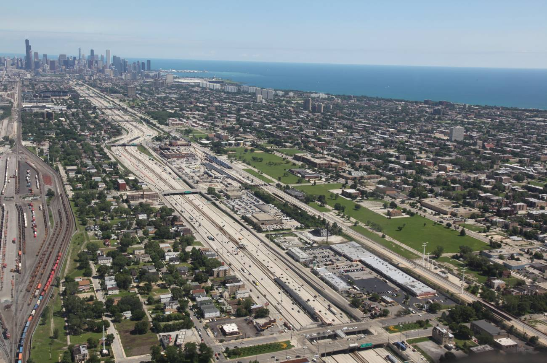
Fig 5. Subtraction (Easterling, 2003). South Side Chicago, July 2010 (author). The empty green corridor to the right of the Dan Ryan Expressway is where the Robert Taylor Homes once stood. The projects were built in the late 1950s on the site of the old Federal Street slum, and demolished beginning in 1998.

Legal Spatial Fixes
Capital’s political reconstruction of scale coincided with detailed changes in the rules governing the most fundamental sector of the urban landscape -- housing. This meant changes in laws about mortgage lending, debt, and banking. The first significant cracks in the foundation of the stable post-war housing system appeared in the late 1970s. The Supreme Court’s 1978 Marquette decision allowed national banks to “take their most favored lender status across state lines and preempt the usury laws of the borrower’s home state.” (McCoy and Renuart, 2008, p. 5). South Dakota and Delaware moved first to repeal usury limits as an economic development strategy, and soon the process of “regulatory exportation” intensified competition that weakened nearly all states’ usury laws. Then, in response to the corrosive inflation and disintermediation of the late 1970s, Congressed passed the Depository Institutions Deregulation and Monetary Control Act (DIDMCA) of 1980. DIDMCA eliminated interest rate caps for first-lien residential mortgages, and allowed other types of depository lenders (not just national banks) to take advantage of the Marquette decision (McCoy and Renuart, 2008). Shortly thereafter, the Alternative Mortgage Transactions Parity Act (AMTPA) preempted, for nearly all types of lenders, state restrictions on “alternatives” from the standard, fully-amortized fixed-rate loan -- allowing variable rate terms, negative amortization, balloon payments, and other creative options. The interactions between Marquette, DIDMCA, and AMTPA created intricate, non-Euclidian spaces of permissible financial transactions: Marquette disconnected the rules from the state where a borrower lived, DIDMCA freed depository lenders from common state restrictions, and AMTPA liberalized certain types of non-traditional loans, regardless of whether they were made by deposit-taking banks or independent mortgage companies.
These laws provided the necessary conditions for the growth of high-risk mortgage lending, and by the 1990s the market was studded with a variety of niche subprime products targeted towards inner-city neighborhoods and mobile-home owners, particularly in renovation and refinance lending (Mansfield, 2000). The sufficient conditions for a broader expansion required other changes in technology, regulation, financial competition, and transnational investment. Enhanced consumer credit surveillance, credit scoring, default modeling, and automated underwriting promised increased accuracy in extracting profits from consumers once viewed as too risky to serve (Miller et al., 2003). Mortgage-backed securities, launched tentatively in 1968 by the government-sponsored Ginnie Mae, finally began to grow after the 1984 Secondary Mortgage Market Enhancement Act resolved tax issues and state regulations (Johnson and Kwak, 2010, p. 73). At the time, however, secondary market growth was slowed by the exploding savings and loan crisis -- itself a product of deregulation -- and the bad publicity made it hard for Wall Street’s lobbyists to achieve more sweeping relaxation of Depression-era laws on securities and banking. Yet whenever regulatory capture and pressures on lawmakers failed, entrepreneurial innovation in legal evasion took up the slack: Wall Street quickly found new ways to subvert the old laws through products that fell through the cracks of existing laws, regulations, or narrow paths of enforcement. The products fell through the cracks because they were designed exactly for this purpose. One example comes from the bizarre, obscure legal entities that collapsed in 2007, sending shock waves through all the other kinds of institutions up until the disastrous weeks of September and October, 2008. These legal entities were sole-purpose companies established to manipulate the flow of mortgages and other asset-backed securities that were growing so rapidly. Sometimes these entities were called Special Purpose Entities (SPEs), sometimes Special Purpose Vehicles (SPVs). Much of what makes them special is that they break the chain of legal liability for certain violations of law committed when the borrowers signed the mortgage documents.
Another factor was the strange story of the fear of budget surpluses. Projecting surpluses to infinity under then-current budget laws, Clinton’s Treasury Department announced plans to retire its 30-year “long bond” in 2001. Suddenly, the universally-recognized global safe harbor and benchmark for evaluating debt and credit risk was set to disappear, and institutional investors around the world cast about for alternatives (Wiggins and Boland, 2001). The securities of the Government Sponsored Enterprises (GSEs), Fannie Mae and Freddie Mac, became popular replacements (Hershey, 2002). They were soon joined by the private-label mortgage-backed securities offered in ever-greater volume by the growing, deregulated Wall Street investment banks (Johnson and Kwak, 2010).
So far, so good. All of this regulatory history is now well known (Crump et al., 2008; Engel and McCoy, 2002; Immergluck, 2004, 2009; Newman, 2009; Squires, 2003). What makes it relevant to our claims about a new spatiality of home in America is the peculiar configuration of banking and financial regulation in American federalism. From the earliest days of the republic, the states viewed any kind of federal initiative in the realm of finance -- a common currency, the creation of a central bank -- as a dangerous threat to their sovereignty. Between Andrew Jackson’s veto of the Second Bank of the United States in 1832 to the creation of the Federal Reserve in 1913, many of the state-federal tensions were negotiated only through a complex web of functional and geographical-legal divisions that placed careful limits on federal power. Once again, space was the fix. Only the Great Depression brought clear and consistent federal regulation -- and even then, the most potent interventions were laid atop the existing framework that already divided national and state banks. There has never been a single regulator, therefore, supervising institutions involved in mortgage finance. Supervision depends on whether an institution has a state or national charter; whether it accepts customer deposits or exists solely to make mortgages; and whether it serves a mixture of business and consumers, or functions solely as a savings and loan. By the late 1990s, the mortgage market was split across six regulatory agencies: the Office of the Comptroller of the Currency (OCC), the Federal Reserve Board (FRB), the Federal Deposit Insurance Corporation (FDIC), the Office of Thrift Supervision (OTS), the National Credit Union Administration (NCUA), and the U.S. Department of Housing and Urban Development (HUD).
After the repeal of Depression-era banking laws with the Gramm-Leach-Bliley Act in 1998, the regulatory matrix become even more complex with large, multi-subsidiary holding companies (Acharya et al., 2010). George W. Bush’s federal agencies led the way, “pre-empting” state laws on predatory lending for federally-regulated lenders (Engel and McCoy, 2011), while in Watters v. Wachovia the Supreme Court struck down even modest requirements for subsidiaries of national banks to register to do business in a state.
This all makes for complicated geographies. While Adams (1986, p. 234) hoped for a “renewed emphasis on shelter and neighborhood,” deregulation and financialization created an intricate landscape of institutions whose behavior could not be regulated by local rules, or increasingly, by state laws (preempted by weak federal rules). The where of a consumer’s interaction with mortgage finance still mattered to local brokers and small-time mortgage firms, but more of these local actors brought their business to (or were acquired by) the large, multi-subsidiary national banks and holding companies. For these dominant firms, subsidiary-structure, preemption, and financial deregulation created a thoroughly post-Cartesian, non-Euclidian space of law and accumulation.

Data
To map some of these new realities of American housing, we need detailed information on the individuals and institutions involved in housing market relations that operate at multiple spatial scales. We exploit several under-utilized features of a widely-used data source, the Home Mortgage Disclosure Act. Each year, portions of the raw loan-application register (LAR) and institutional transmittal sheet (TS) data are disclosed under HMDA (FFIEC, annual). HMDA records provide a limited set of variables measuring the characteristics of loan applicants, the outcome of applications, and a proxy of subprime status based on a “rate spread” calculated from a benchmark of prevailing interest rates (FFIEC, 2006a, 2006b). These data are widely used to document various kinds of inequalities in the allocation of credit. We use the data for this purpose, but we also take advantage of the little-noticed possibilities for analyzing the characteristics of institutions in an industry that has undergone dramatic, turbulent innovation in recent years. We built several databases for the peak year of the subprime boom (2006), aggregating the 34.1 million applicant records to develop market specialization measures for each of the 8,886 separate organizations filing disclosure reports. These lender-level summaries are then merged with a more specialized institutional database compiled by the Federal Reserve (Avery, 2009) to track the increasingly complex structure of bank and financial holding companies and their many subsidiaries. Then we merge the detailed lender databases with the applicant records for conventional loan originations collateralized by single-family homes in the 1,086 metropolitan counties across the continental U.S. Finally, we enhance the database with the detailed analysis of state laws on subprime and predatory lending built by Bostic et al. (2008).
These databases provide an exceptionally detailed view of borrowers obtaining mortgage credit for homes in different cities and suburbs, and of the various lenders providing that credit -- banks, thrifts, and mortgage companies, and their “parent” conglomerates and bank holding companies. Since HMDA records also indicate whether a loan was sold in the same calendar year as origination, we also have a partial view of the securitization networks that were so decisive in transforming local mortgages into “electronic instruments” (Sassen, 2009) and “postindustrial widgets” (Newman, 2009) in an expanding transnational network of debt and investment (Gotham, 2009). The database is far from perfect: industry lobbyists never tire of pointing out that HMDA includes no measures of applicant creditworthiness (an absence that reflects the hard work of lobbyists who fought proposals to add credit history to HMDA several years ago; see Immergluck, 2004). Yet the database provides the broadest possible coverage of the market and some of the corporate actors involved in the “front end” of loan origination.
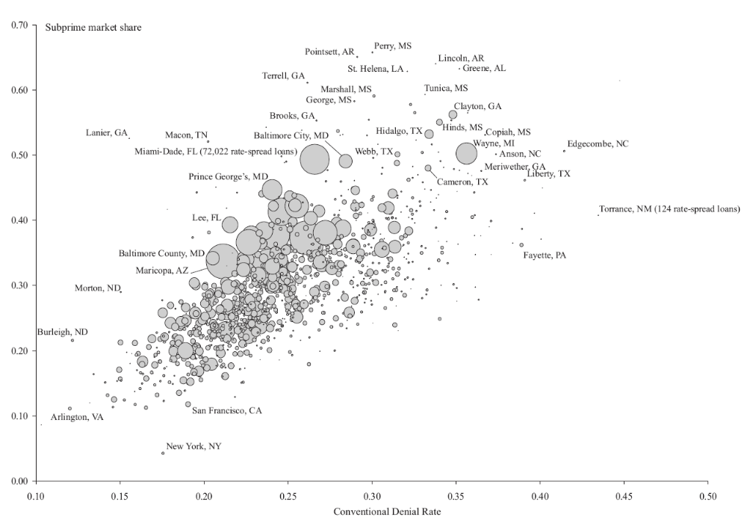
Fig. 6. American Inequality, Old and New: Conventional Mortgage Denial Rates and Rate-Spread Market Penetration, by County. Circle sizes are scaled proportional to total number of rate-spread originations. Data Source: FFIEC (2007).

Two Views of Subprime America
Consider a simple graph of the relations between the old and new regimes of mortgage credit (Fig. 6). Subprime market penetration rises smoothly with increasing local denial rates. Approximately half the variance in subprime market share in the nation’s metropolitan counties can be attributed to a single factor -- differences in conventional mortgage denial rates. This relationship nicely captures the essence of the policy and ideological stalemate over predatory lending, regulation, and risk-based pricing. For de-regulatory conservatives, the relationship demonstrates that subprime lending serves those places where borrowers cannot qualify for mainstream, prime credit. For community reinvestment advocates and critical scholars, the relationship demonstrates that the new inequalities of high-cost, high-risk credit simply exacerbate the old-fashioned inequalities of exclusion, redlining, and discrimination. For our purposes here, the key question involves geographical contingency. Is the general relationship between the old patterns of denial and the new contours of subprime inclusion more important than the exceptional outliers -- the distinctive circumstances of particular regions, cities, or suburbs? Not surprisingly, the eye is drawn to the large circles representing the big markets with the highest subprime market penetration -- Miami-Dade, Florida, and Wayne County, Michigan (Detroit).
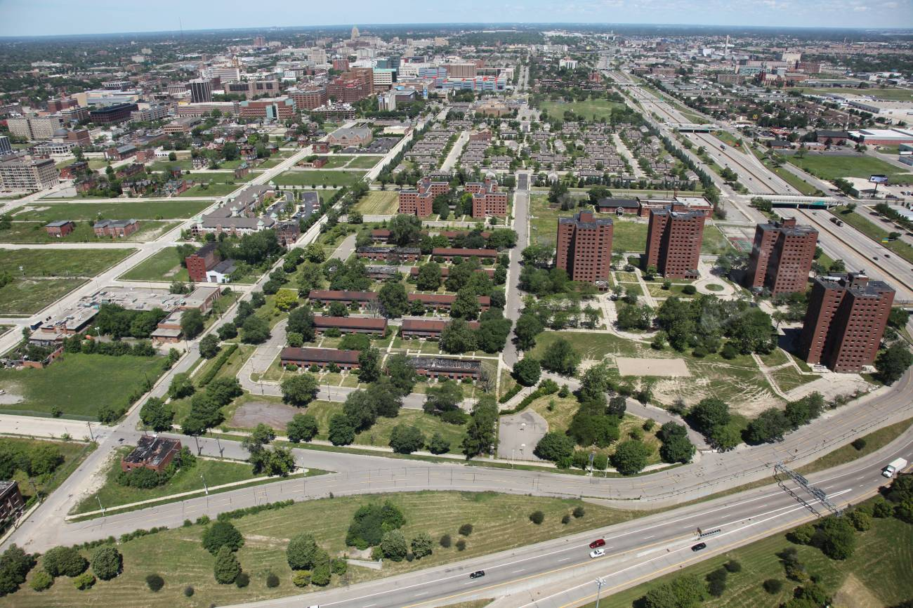
Fig 7. Global Subprime Capital Lands in Detroit. July 2010 (author). The view is to the north-northwest, just beyond Detroit’s downtown core. In the foreground are the Brewster-Douglass Housing Projects, built on the site of Detroit’s Black Bottom community. Wayne County, Michigan is the nation’s largest urban area with the worst combination: high mortgage denial rates and deep subprime market penetration. Blacks were more likely to be pushed into subprime loans compared with whites with similar incomes, and this disparity was deeply intertwined with neighborhood segregation.

Yet even more extreme cases at the top of the graph highlight a vast, diverse array of landscapes across the South -- from the border cities of South Texas (Hidalgo County, just north of McAllen) to the growing suburban Black middle class communities south of Atlanta (Clayton County, Georgia), to several small-town counties across Louisiana, Alabama, Mississippi, and Arkansas.
Now consider a second set of views that focus explicitly on race/ethnicity and place (Figures 8, 9). The interaction between past and present becomes clear in the divergent landscapes of subprime loans to African-American and Latinas/Latinos. For African-Americans, the pattern still reflects the antebellum settlement fabric of small towns that emerged from the old plantation network across the Piedmont South, from Virginia to Mississippi (duBois, 1903). Yet the Great Migration between the First and Second World Wars also made the “dream of Black Metropolis” a reality in Harlem, Chicago’s South Side, Detroit, and other expanding industrial centers of the North (Boyd, 2011). After the Civil Rights movement of the 1960s, service sector growth in the rising sunbelt nourished a growing black middle class in Atlanta, while federal efforts to rectify discriminatory hiring and promotion in the civil service made the suburbs of Washington, DC an epicenter of African-American upward mobility. For Latinas and Latinos, by contrast, the housing and credit boom was deeply regionalized in the urban landscapes of Southern California, Florida, Texas, and Arizona. Even so, recent growth has also transformed the housing markets of Chicago, the Boston-Washington corridor, and a growing number of cities in the “New South” (Smith and Furuseth, 2006).
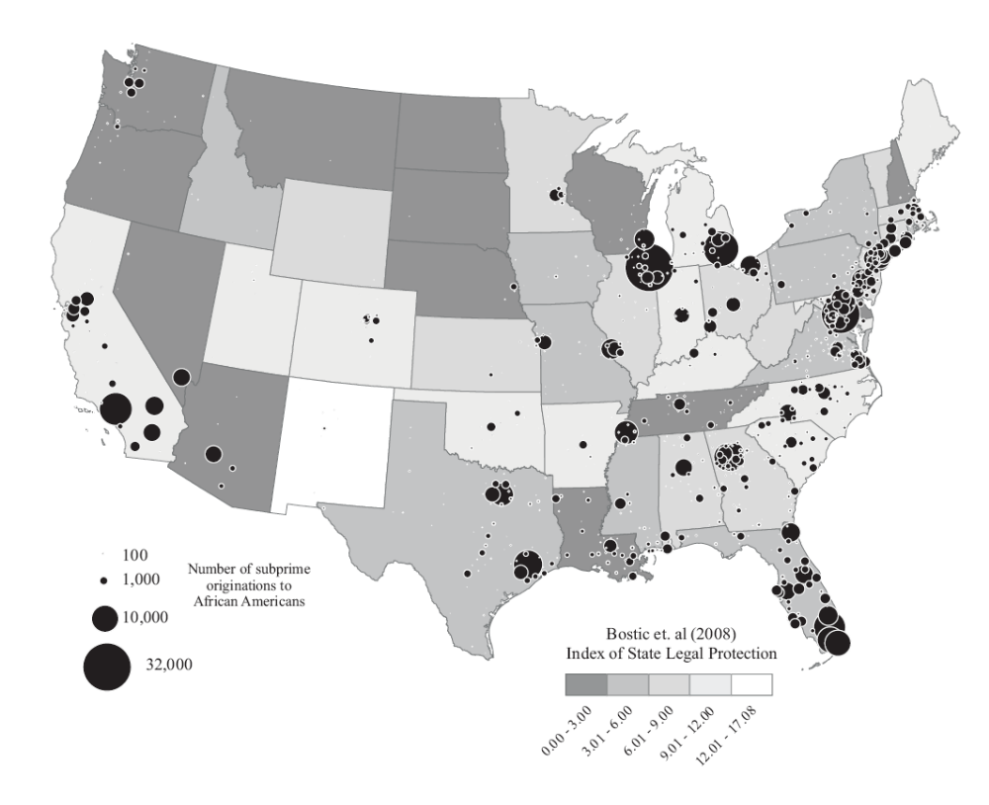
Fig 8. Subprime Loans to African-Americans and State Regulation. Data Sources: FFIEC (2007), Bostic et al. (2008).

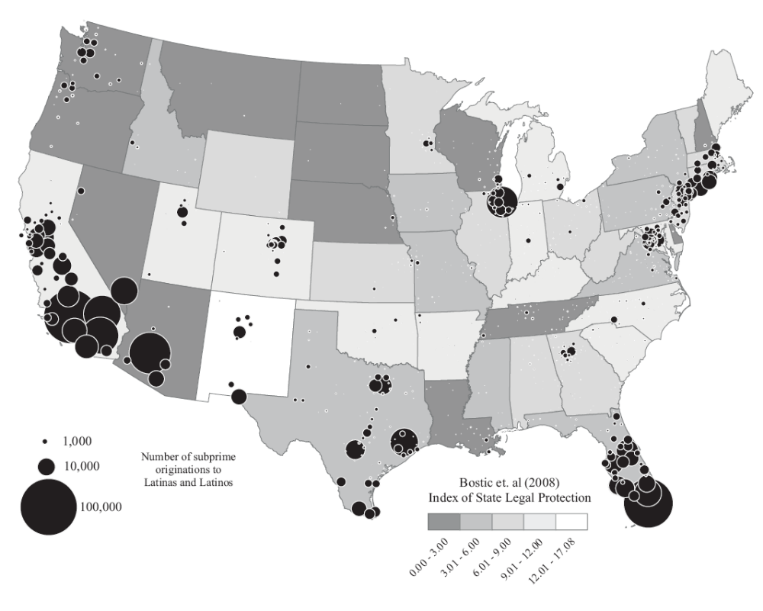
Fig 9. Subprime Loans to Latinos and Latinas, and State Regulation. Data Sources: FFIEC (2007), Bostic et al. (2008).

Geography clearly matters. Yet space and place cannot be reduced to simple, deterministic causal relationships. When individual borrower outcomes are modeled, a standard vector of county-level variables adds very little explanatory power to logistic regressions of the prime/subprime dichotomy after controlling for applicant income, loan amount, and other relevant characteristics. But the fact that geographies of credit are not always easy to model in a causal, additive framework does not mean that place is irrelevant. Market outcomes vary widely even after accounting for a wide range of borrower- and lender-level characteristics (Table 1). Compared with otherwise similarly qualified non-Hispanic Whites, African-American
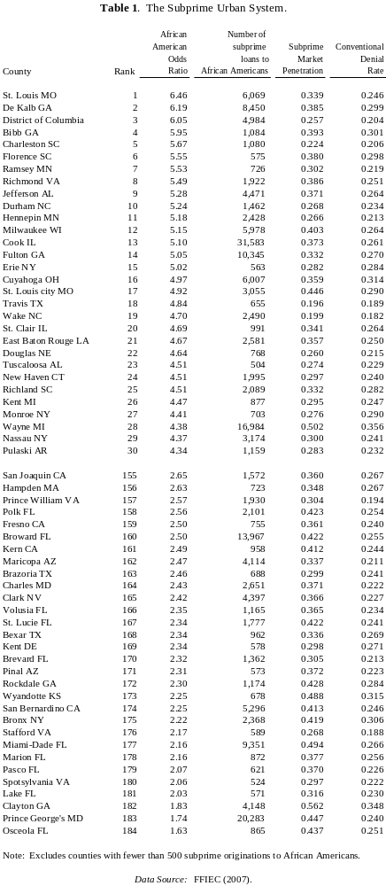
homeowners and homebuyers in the suburbs of St. Louis, Missouri are six and a half times more likely to wind up with high-cost credit. This ratio drops to 1.74 for African-Americans in Prince George’s County, one of the nation’s largest communities of Black Middle Class professionals in the suburbs of Washington, DC. Variations in Black-White disparities are not entirely random: the worst inequalities appear in the South and East, with only three of the worst-thirty counties West of the Mississippi, in Arkansas, Nebraska, and Texas. The West, by contrast, is more prominent in the places with lower disparities towards the bottom of the list. Unequal geographies of credit seem to constitute a separate, independent axis of racial inequality.

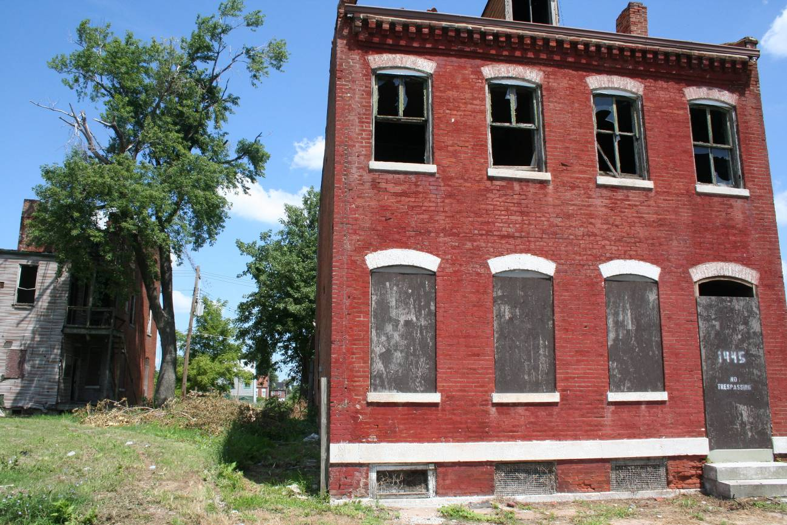Fig. 10. St. Louis, Missouri, August 2007 (author). Comparing the odds of receiving high-risk subprime loans among Whites and otherwise similar African-Americans gives us what we might call an “exploitation ratio” for America’s mortgage mode of accumulation. In the city of St. Louis this ratio is almost five; in the county, it’s well over six. These inequalities are tightly integrated into transnational investment and debt markets. Todd Swanstrom (2011) estimates that direct costs of recent foreclosures in St. Louis County approach $1 billion.

Alternative Cartographies
Understanding a map of America today requires us to see states, cities, and neighborhoods from the perspective of finance capital. This means taking seriously Peter Gould’s (1986, p. 202) quip that “space is not a wastepaper basket that sits there waiting for us to fill it with things, but something we define to suit our needs.” Multidimensional scaling provides an alternative cartography that requires us to be very specific about needs and purposes -- replacing the Cartesian latitude-longitude coordinates with mathematical representations derived from a series of chosen measurements (Kruskal, 1964; Kruskal and Wish, 1978). Our chosen measures offer a portrait of the subprime lending boom and the housing crash in the context of state laws that were on the books in 2004-2005 (Bostic et al., 2008).
The resulting two-dimensional mathematical projection charts the contours of a painful housing collapse (Figure 11). This is not a chart, but a map: states to the “south” on this map have laws establishing standards well above the weak federal limits. The strongest state laws are found south of a line running just above New Jersey, DC, and New York, and extending south of Colorado to curve up, including Georgia and Texas. Highly-leveraged subprime borrowers with low credit scores are more prevalent to the “east,” while low-doc loans are more common to the “west.” The housing boom drove prices up the most in the north-west quadrant of the map, and it is here where prices fell the furthest in the crisis: on the ride up from 2001, real house prices increased more than 90 percent in an arc stretching from New York through what the business press dubbed the “sand states” (California, Florida, Nevada, and Arizona) to Maryland; by early 2010, prices had fallen at least 39 percent in the sand states. Fully 30 percent of the subprime loans outstanding in Florida were in some stage of foreclosure in May, 2010.
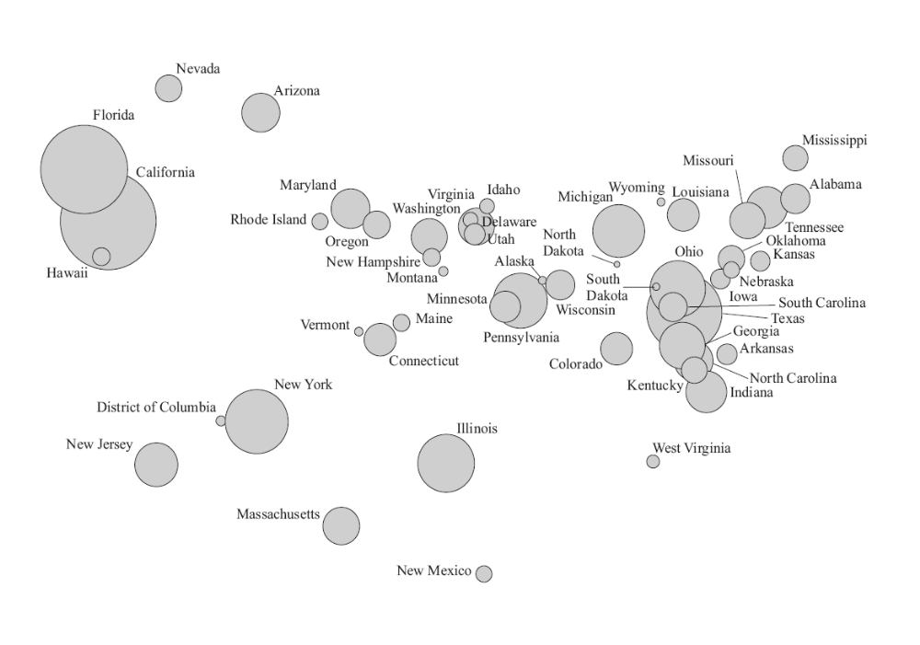Fig. 11. U.S. States in Housing Finance Space, 2004-2010. Map created with classical multiple dimensional scaling algorithm. Circle sizes are scaled proportional to total number of rate-spread originations. Data Sources: FFIEC (2007), Federal Reserve Bank of New York (2010), FHFA (2011).

This alternative cartography presents an unusual view of the states, but it is not entirely abstract. The upper-right-hand section of the map has few state restrictions, generally higher subprime market penetration, and a subprime profile oriented towards highly-leveraged, low-credit borrowers; most of the Confederacy remains in this section of the map, a reminder that “a pall of debt” still “hangs over” the land more than a century after duBois’s (2003[1903], p. 92) eloquent analysis. From the perspective of lenders and the housing boom, the mid-section of the map stretches all the way from Oregon to Montana, Michigan, and Pennsylvania, with middle-range scores on most indicators. The regulatory battlegrounds are New Jersey, New York, Massachusetts, Illinois, and New Mexico. New Mexico stands out as exceptional, with Governor Bill Richardson working with a coalition of church officials to pass major predatory lending legislation in 2003 (Lampman, 2007). But in the non-Euclidian space of housing finance and regulation, the state next door is far away, at the epicenter of deregulatory growth that collapsed in California, Florida, Nevada, and Arizona (Combs, 2006).
Other spatial contortions are apparent elsewhere on the map: New York is right next to Washington, DC, which is itself reconfigured in turn by legal geographies. In terms of consumer protection, the leafy streets of Northwest Washington and the disinvested blocks of Anacostia are closer to the distant, working-class small towns of the Appalachian ridge-and-valley section of West Virginia than to the adjacent suburbs of Maryland and West Virginia. And in one of those Virginia suburbs, about half of all the debt claims of mortgage borrowers across all of America’s states, cities, and suburbs are legally claimed by a single company, Mortgage Electronic Registration Systems (MERS)(Powell and Morgenson, 2011).
Capital and law are constantly reconstructing this map of American federalism, and the ongoing struggles of governors, legislators, judges, and lawyers present a complex narrative of change in what kinds of activities are allowed and encouraged in housing finance.
Securities, Subsidiaries, and Space
Can we disentangle the individual, institutional, and geographical aspects of the subprime boom? One approach is to use a multivariate model to analyze the differences between borrowers who get prime, mainstream credit, versus those who wind up with high-cost subprime loans. Including controls for borrower characteristics allows us to test for independent effects of securitization networks and regulation on the allocation of subprime credit (Table 3).

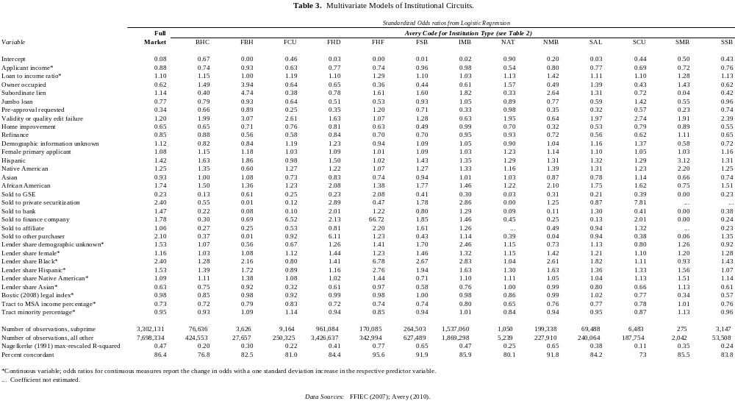
For the market as a whole, the results for applicant and loan characteristics present a profile that is by now quite familiar (cf. Crump et al., 2008; Immergluck, 2004, 2009; Squires, 2003). All else constant, high-cost credit is more likely among lower-income borrowers with higher estimated debt ratios, particularly African-Americans (odds ratio of 1.74) and Latinas/Latinos (1.42). These inequalities are upwardly biased by the absence of creditworthiness controls, but they are downwardly biased by the models’ inclusion of factors that are well beyond the influence of applicants’ qualifications or choices -- in particular, the lender’s decision whether to sell the loan on the secondary market. Secondary-market networks are crucial in driving subprime lending: compared to loans held on the books, a mortgage sold to a purchaser in the “other” category (typically, a special purpose vehicle or “SPV”) is 2.1 times more likely to be subprime. Subprime credit is also closely tied to lender specialization: increasing a lender’s African-American share of originations by one standard deviation increases the likelihood that a borrower will wind up with a subprime loan by a factor of 2.40 -- even after accounting for the borrower’s individual characteristics, including race and ethnicity. Credit outcomes, in other words, cannot be explained solely in terms of borrowers’ needs or characteristics, but also depend on factors decided by industry actors.
Regulatory climate also matters, but only for those institutions that have not reorganized themselves to evade restrictions. For the market overall, Bostic et al.’s (2008) measure of state lending laws proves statistically meaningless. The insignificance of state laws reflects the interplay of longstanding federal laissez-faire attitudes towards high-risk industry innovations, and the success of conservative forces in Washington in promoting an “active obstruction of state and local legislative attempts to rein in predatory lending.” (Engel and McCoy, 2011, p. 9).
Three other results stand out. First, the individual profile of borrowers -- class, race, and ethnicity -- varies widely across different institutional niches. Second, securitization circuits vary considerably. The only consistent finding is that the GSEs “followed rather than led Wall Street and other lenders in the rush for fool’s gold” (FCIC, 2011, p. xxvi). Compared to loans held on the books, GSE sales are only 0.23 times as likely to be subprime, and this effect holds across all but one of the regulatory categories -- financial holding companies organized as foreign banking organizations. The largest player in this category is HSBC, whose 2002 purchase of the notorious subprime lender Household International accelerated the transnational integration of high-risk American borrowing with the high net savings rates of Asian depositors (Sorkin, 2002; Lewis, 2010, pp. 16-18). 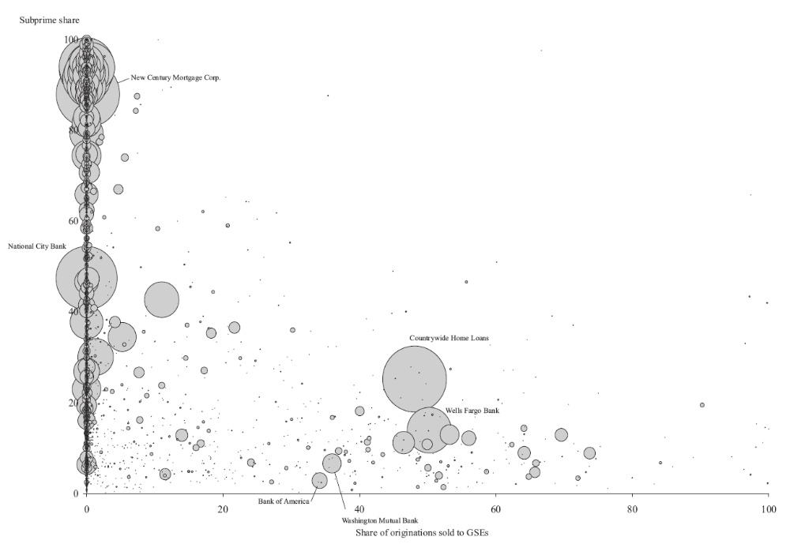
Fig. 12. Same-Year Mortgage Sales to GSEs and Subprime Share. Circle sizes are scaled proportional to total number of rate-spread originations. Data Source: FFIEC (2007).

For all 8,886 lenders in the market, the separation between GSE sales and private, subprime securitization is clear (Figure 12). The largest exception, Countrywide, is a deeply ironic case. Countrywide CEO Angelo Mozilo famously declared in a Milken Institute speech that the firm was forced to lower its lending standards, and “The industry faced special pressure from minority advocates to help people buy homes” (Morgenson and Fabrikant, 2007, p. B1). Investigative journalists later discovered exactly where the pressure had come from. Shortly after becoming chief executive of Fannie Mae, Daniel H. Mudd traveled to Mozilo’s California office, where Mozilo warned him that Fannie’s reluctance to buy the firm’s more risky loans threatened their longstanding partnership; Countrywide now had the option of bypassing the GSEs and selling directly to Bear Stearns, Lehman Brothers, and Goldman Sachs. “You’re becoming irrelevant,” Mozilo reportedly told Mudd; “You need us more than we need you ... and if you don’t take these loans, you’ll find you can lose so much more.” (Duhigg, 2008).
Third, local geography is paradoxical. Clearly, geography does matter in the mixture of prime and subprime credit across the urban system -- high-cost market penetration ranges from about ten percent in Manhattan, San Francisco, and Arlington to more than fifty percent in the small towns of the Mississippi Delta, the Georgia piedmont, South Texas border counties, and Detroit (Figure 6). But when we control for the characteristics of borrowers and the decisions of lenders selling into the secondary market, adding geographical variables makes little difference. This does not mean that local variations are insignificant -- just that these local variations can be explained in terms of targeting and discrimination against certain borrowers by different kinds of institutions. Inequalities once understood as local, neighborhood-level processes have been interwoven with national and transnational investment circuits.
Working in the complex, deregulated spaces of federalism, financial institutions quite literally created the unequal spaces of risk that culminated in the worst financial collapse and foreclosure crisis since the Great Depression. We can measure the institutional complexity of these inequalities by modeling racial disparities in subprime origination across all of the multiple regulators and parent-company corporate structures allowed by Gramm-Leach-Bliley. Subprime selection models for the 41 separate combinations reveal remarkable variation, but consistent racial inequality (Figure 14). Most subprime borrowers wound up dealing with institutions that had “average” racial disparities of 3 or 4 to one for African-Americans, and 2 or 3 to 1 for Latinas. But some channels were much, much worse.
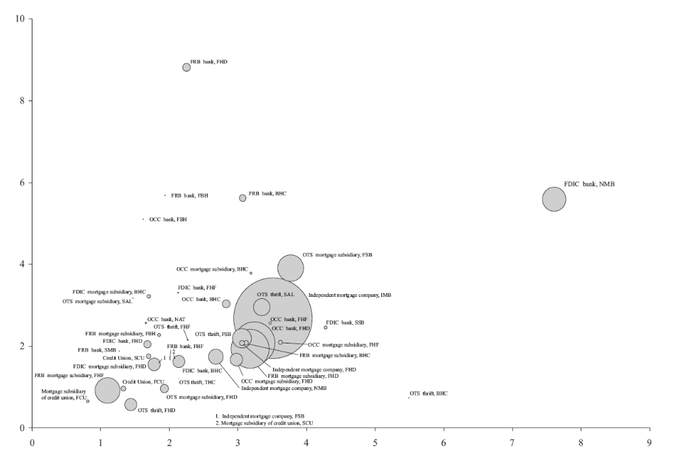Fig. 13. Racial Inequalities and Institutional Structure. Odds ratios for subprime segmentation for non-Hispanic African-Americans (horizontal axis) and for Hispanics (vertical). Circle sizes are scaled proportional to total number of rate-spread originations. Data Sources: FFIEC (2007), Avery (2010).

Conclusions: A Paler Shade of the American Racial State?

“As he traveled across South Carolina on Tuesday, Mr. Santorum ... said the party can win back the White House only by offering a ‘clear contrast’ with President Obama.

‘We need contrasts,’ Mr. Santorum said, ‘not just a paler shade of what we have.’”
(Zeleny, 2012).

Housing in America, once the foundation of a national identity of domestic family security and economic upward mobility, is deeply unstable in today’s rapidly-shifting racial state. Housing was at the birth of America’s latest lurch to the right: Rick Santelli’s call for “a tea party” went viral after the financial anchor screamed about “bailing out the losers” when news broke in early 2009 that the Obama Administration was considering plans to write down a small part of the principal for some mortgages. The Administration quickly backed off, and was only able to get Congress to agree to very limited programs helping borrowers -- most of them requiring the voluntary participation of mortgage servicers. By one measure -- the signs glimpsed by bank stock analysts scrutinizing earnings statements from the fourth quarter of 2006 -- we are now half a decade into the American Housing Depression. By the time the Republican primary contest heated up in early 2012, the American Right had managed to restore the ideological stability of capital accumulation, consumer responsibility, and corporate rights. Gone was the “shocked disbelief” of a Fed Chairman forced to admit in open Congressional testimony that his “whole intellectual edifice” had collapsed. Once again, the national conversation went back to the Right’s familiar Reagan mantra: government isn’t the solution to the problem, government is the problem (Harvey, 2005; Peck, 2010). It’s all about debt and too much government spending.
American capital achieves its fixes through a hybrid racial state. One part of the racial state is the fluid, dynamic interplay of images, discourses, and ideologies used to fight over the meanings of racial categories, and their political mobilization (Omi and Winant, 1994; Goldberg, 2002; Peck, 2010). Thus we have Herman Cain’s meteoric trajectory as a one-hit-wonder Republican primary candidate achieving popularity with his “9-9-9” tax plan that maps the way to the Steve Forbes flat-tax world. When sexual harassment allegations sent Cain’s campaign into a nosedive, Cain joked that he wondered if Anita Hill might not endorse him. A few months later he appeared on Bill Maher’s “Real Time” in front of a poster advertising the “documentary” film Runaway Slave: From Tyranny to Liberty. Runaway Slave “discovers the unknown history of the Civil Rights Movement,” and “exposes the NAACP as a mouthpiece of the Democratic Party, and the NAACP’s leaders as the ultimate ‘race hustlers’ who perpetuate -- and profit -- from a victim mentality that hurts the African-American community.” (Kibbe, 2012). Produced by Dick Armey’s FreedomWorks, Runaway Slave declares that “while the African-American community has triumphed over the scourge of physical slavery, many still suffer from a mental slavery -- to government.” (Kibbe, 2012).
This simulacra racial state moves fast: racial images, categories, and politics move like mercury. It does have serious performative consequences, and thus the critical Left must always be in the arena to challenge the evasive new constructions of white privilege manufactured by the powerful coalitions of capital and racism. But another part of the project must devote attention to the old-fashioned material inequalities that are still quite literally located in real places and real neighborhoods. Geography is not dead. This part of the American racial state is much more stable, etched into the urban landscape by history, demography, and all the hidden biases of market practices and public policies. These local outcomes have remained deeply racialized since the 1960s, producing remarkably similar spatial inequalities even as the old forms of discriminatory exclusion were replaced by new forms of segmented inclusion into expanding circuits of risk.
America’s subprime boom reconfigured the scale of class-monopoly rent (Harvey, 1973). Local loan sharks were replaced by a vast food chain of predators in pinstripes, each claiming a share of the surplus value extracted from borrowers, or of the fee income thrown off by the manufacture of fictitious mortgage capital. Loan sharks know they’re loan sharks. But today’s predators deny all intent to deceive, or discriminate. For many, this claim may be an honest defense: millions of ordinary middle-class investors around the world received quarterly financial statements on portfolios that, inevitably, included substantial investments in mortgage-backed securities -- many of them those famous “tranches” backed by the monthly payments of subprime borrowers who may have been pushed into usurious obligations by deceptive local brokers. But we can acknowledge the absence of discriminatory intent in the newly transnationalized commodity chain of class-monopoly rent, without denying the persistence of deeply racist processes, structures, and outcomes: this is the crucial legal distinction between disparate treatment and disparate impacts. Individual agency matters less than the powerful structures of law and capital accumulation. And we will be living with the deeply racialized spaces of local, neighborhood segregation and white privilege in American housing for quite some time.
The evidence presented in this paper documents the crucial role of institutional spaces: corporate organization and securitization became decisive factors in the allocation of prime and subprime credit, while executive, legislative, and judicial decisions helped to create a complex, post-Cartesian map of state-federal relations that shaped local experiences in regional housing markets. Our maps and models, of course, present just one snapshot of one kind of housing inequality at one point in time. Various provisions of the Dodd-Frank financial reform legislation passed in the summer of 2010 have the potential to create new maps, and new federal-state spaces. It remains to be seen, however, whether Republicans will succeed in their attempts to starve funding to prevent implementation of the law’s more important reforms. What is clear is that if we want to redefine housing in the twilight of materialism, we will have to fight for it: a “renewed emphasis on shelter and neighborhood” will only be possible if we challenge all the institutions and people, from Baltimore to Brussels to Beijing, who remain enamored by “the false hope that everyone can get rich from real estate.” (Adams, 1986, p. 234).
References

Aalbers, M.B. (2008) The financialization of home and the mortgage market crisis, Competition & Change 12(2) pp. 148-166.

Abler, R., J.S. Adams, and P. Gould (1971) Spatial Organization: The Geographer’s View of the World (Englewood Cliffs, NJ, Prentice-Hall).

Acharya, V.V., T.F. Cooley, M.P. Richardson, and I. Walter (Eds) (2010) Regulating Wall Street: The Dodd-Frank Act and the New Global Architecture of Global Finance (Hoboken, NJ, Wiley).

Adams, J.S. (1986) Housing markets in the twilight of materialism, Professional Geographer 38(3) pp. 233-237.

Adams, J.S. (1984) The meaning of housing in America, Annals of the Association of American Geographers 74(4) pp. 515-526.

Adams, P.C. (1996) Protest and the scale of politics in telecommunications, Political Geography 15(5) pp. 419-499.

Anderson, J. (2004) Spatial politics in practice: The style and substance of environmental direct action, Antipode 36(1) pp. 106-125.

Andrews, E. (2009) Bernanke, a hero to his own, can’t shake critics, New York Times August 20 p. A1.
Ashton, P. (2009) An appetite for yield: The anatomy of the subprime crisis, Environment and Planning A 41(6) pp. 1420-1441.

Avery, R. (2009) HMDA Lender File, 2008 Filing Year (Washington, DC, Board of Governors of the Federal Reserve).

Beauregard, R.A. (1994) Capital switching and the built environment, United States, 1970-89, Environment and Planning A 26 pp. 715-732.

Beck, N., K.S. Gleditsch, and K. Beardsley (2006) Space is more than geography: Using spatial econometrics in the study of political economy, International Studies Quarterly 50 pp. 27-44.

Belluck, P. (1998) End of a ghetto: A special report. Razing the slums to rescue the residents, New York Times, September 6.

Bernanke, B. (2005) The Global Saving Glut and the US Current Account Deficit (Richmond, Virginia Association of Economists, March 19).

Blomley, N.K., D. Delaney, and R.T. Ford, eds (2001) The Legal Geographies Reader: Law, Power, and Space (Oxford: Blackwell).

Bostic, R.W., K.C. Engel, P.A. McCoy, A. Pennington-Cross, and S.M. Wachter (2008) The Impact of State Anti-Predatory Lending Laws: Policy Implications and Insights (Cambridge, MA, Harvard University Joint Center for Housing Studies).

Boyd, R.L. (2011) New York, Chicago, and the ‘black metropolis’ of the early 20th century, Urban Geography 32(7), 1066-1083.

Brenner, N. (2000) The urban question as a scale question: Reflections on Henri Lefebvre, urban theory, and the politics of scale, International Journal of Urban and Regional Research 23(2) pp. 361-378.

Brubaker, H. (2007) Fulton may be required to buy back failed loans, Washington Post March 28 p. C1.

Castells, M. (2010) Rise of the Network Society, Second Edition (Chichester, Wiley-Blackwell).
Christophers, B. (2011) Revisiting the urbanization of capital, Annals of the Association of American Geographers 101(6) pp. 1347-1364.

CNN (2012) Republican Primary Debate, January 26. Atlanta: Cable News Network, Inc.

Combs, C.L. (2006) Banking law and regulation: Predatory lending in Arizona, Arizona State Law Journal 38 p. 617.

Cox, K. (1998) Spaces of dependence, spaces of engagement, and the politics of scale, or: Looking for local politics, Political Geography 17(1) pp. 1-23.

Crump, J.R., K. Newman, E.S. Belsky, P. Ashton, D.H. Kaplan, D.J. Hammel, and E. Wyly (2008) Cities destroyed (again) for cash: Forum on the U.S. foreclosure crisis, Urban Geography 29(8) pp. 745-784.

Dennis, B. (2011) The foreclosure crush, Washington Post, October 15, A1.

du Bois, W.E.B. (2003[1903]) The Souls of Black Folk (New York, Barnes and Nobles Classics).

Dugan, J.C. (2010) Statement of John C. Dugan, Comptroller of the Currency, Before the Financial Crisis Inquiry Commission (Washington, DC, U.S. Department of the Treasury, April 8).

Duhigg, C. (2008) Pressured to take more risk, Fannie reached tipping point, New York Times October 5, p. A1.

Dymski, G. (1999) The Bank Merger Wave (Armonk, NY: M.E. Sharpe).

Easterling, K. (2003) Subtraction. Perspecta 34, 80-90.

Elazar, D.J. (1970) American Federalism: A View from the States, Second Edition (New York, Crowell).

Engel, K.C., and P.A. McCoy (2002) A tale of three markets: The law and economics of predatory lending, Texas Law Review 80(6) pp. 1255-1381.

Engel, K.C., and P.A. McCoy (2011) The Subprime Virus (New York, Oxford University Press).

Federal Financial Institutions Examination Council (FFIEC) (Annual) Home Mortgage Disclosure Act, Raw Data (Washington, DC, Federal Financial Institutions Examination Council).

Federal Financial Institutions Examination Council (FFIEC) (2006b) Frequently Asked Questions about the New HMDA Data (Washington, DC, Federal Financial Institutions Examination Council).

Federal Financial Institutions Examination Council (FFIEC) (2006a) A Guide to HMDA Reporting: Getting it Right (Washington, DC, Federal Financial Institutions Examination Council).

Federal Reserve Bank of New York (2010) Nonprime Mortgage Conditions in the United States (New York, Board of Governors of the Federal Reserve).

Financial Crisis Inquiry Commission (2011) The Financial Crisis Inquiry Report (Washington, DC, National Commission on the Causes of the Financial and Economic Crisis in the United States).

Friedman, T.L. (2007) The World is Flat (New York, Picador).

Goldberg, D.T. (2002) The Racial State (Malden, MA: Blackwell).

Gotham, K.F. (2009) Creating liquidity out of spatial fixity: The secondary circuit of capital and the subprime mortgage crisis, International Journal of Urban and Regional Research 33(2) pp. 355-371.

Gould, P.R. (1986) The Geographer at Work (London, Routledge and Kegan Paul).

Greenspan, A. (2007) US moving closer to recession, Appearance on ABC News This Week 16 December.

Hall, P. (2003) The end of the city? ‘The report of my death was an exaggeration,’ City 7(2) pp. 141-152.

Harloe, M. (1987) Housing in an age of austerity, in: W.V.Vliet (Ed) Housing Markets and Policies Under Fiscal Austerity (New York, Greenwood Press).

Harvey, D. (1973) Social Justice and the City (London, Edward Arnold).

Harvey, D. (1974) Class-monopoly rent, finance capital, and the urban revolution, Regional Studies 8(3/4) pp. 239-255.

Harvey, D. (1978) The urban process under capitalism: A framework for analysis, International Journal of Urban and Regional Research 2 pp. 101-131.

Harvey, D. (1985) The Urbanization of Capital (Baltimore, Johns Hopkins University Press).

Harvey, D. (1989) From managerialism to entrepreneurialism: The transformation in urban governance in late capitalism. Geografiska Annaler 71B, 3-17.

Harvey, D. (2000) Spaces of Hope (Berkeley, University of California Press).

Harvey, D. (2005) A Brief History of Neoliberalism (Oxford: Oxford University Press).

Harvey, D. (2011) The Enigma of Capital (Oxford: Oxford University Press).

Hershey, R.D. (2002) Learning to love Fannie and Freddie, New York Times November 4 p. BU8.

Higginbotham, A.L. (1991) An open letter to Justice Clarence Thomas from a Federal judicial colleague. University of Pennsylvania Law Review 140, 1005-1028.

Hill, A.F. (1995) Marriage and patronage in the empowerment and disempowerment of African-American women, in A.F. Hill and E.C. Jordan, eds., Race, Gender, and Power in America: The Legacy of the Hill-Thomas Hearings (Oxford: Oxford University Press) pp. 271-291.

Hill, A. (2011) Reimagining Equality: Stories of Gender, Race, and Finding Home (Boston: Beacon Press).

Hughes, J.W., and G. Sternlieb (1987) The Dynamics of America’s Housing (New Brunswick, NJ, Center for Urban Policy Research).

Immergluck, D. (2009) Foreclosed (Ithaca, NY, Cornell).

Immergluck, D. (2004) Credit to the Community (Armonk, NY, M.E. Sharpe).

Johnson, S., and J. Kwak (2010) Thirteen Bankers (New York, Pantheon).

Ketcham, C. (2010) Stop payment! A homeowners’ revolt against the banks, Harper’s Magazine, January pp. 28-36.

Kibbe, M. (2012) Runaway Slave Documentary Movie Poster. Image and text posted to Flickr, January 15.

King, R. (1989) Capital switching and the role of ground rent: 1. Theoretical problems. Environment and Planning A 21 pp. 445-462.

Krugman, P. (1998) Space: The final frontier, Journal of Economic Perspectives 12(2) pp. 161-174.

Kruskal, J.B. (1964) Nonmetric multidimensional scaling, Psychometrica 29 pp. 115-129.

Kruskal, J.B., and M. Wish (1978) Multidimensional Scaling (Thousand Oaks, CA, Sage).

Lampman, J. (2007) Bill Richardson: A negotiator’s faith in fairness and finding the common good, Christian Science Monitor December 6 p. 1.

Lefebvre, H. (1991) The Production of Space. Nicholson-Smith, D., trans. (Oxford: Blackwell).

Lewis, M. (2010) The Big Short (London, Allen Lane).

Listokin, D., and S. Casey (1980) Mortgage Lending and Race (New Brunswick, NJ, Center for Urban Policy Research).

Lownestein, K., and A. K. Loury (2008) Lost voters, lost voices. The Chicago Reporter, January 13.

Malveaux, J. (1995) Foreword, in A.F. Hill and E.C. Jordan, eds., Race, Gender, and Power in America: The Legacy of the Hill-Thomas Hearings (Oxford: Oxford University Press) pp. xi-xvii.

Mansfield, C.L. (2000) The road to subprime HEL was paved with good Congressional intentions: Usury deregulation and the subprime home equity market, South Carolina Law Review 51 pp. 473-559.

McCann, E. (2010) Urban policy mobilities and global circuits of knowledge: Toward a research agenda. Annals of the Association of American Geographers 101(1) pp. 107-130.

McCoy, P.A, and E. Renuart (2008) The Legal Infrastructure of Subprime and Nontraditional Home Mortgages (Cambridge, MA, Harvard Joint Center for Housing Studies).

Menard, S. (2002) Applied Logistic Regression Analysis (Thousand Oaks, CA, Sage).

Miller, M.J., ed. (2003) Credit Reporting Systems and the International Economy (Cambridge, MA, MIT Press).

Monroe, S., and P. Goldman (1988) Brothers: Black and Poor: A True Story of Courage and Survival. New York: William Morrow.

Morgenson, G., and G. Fabrikant (2007) Countrywide’s chief salesman and defender, New York Times November 11 p. B1.

Newman, K. (2009) Post-industrial widgets: Capital flows and the production of the urban, International Journal of Urban and Regional Research 33(2) pp. 314-331.

Ogletree, C. (1995) The people vs. Anita Hill: A case for client-centered advocacy, in A.F. Hill and E.C. Jordan, eds., Race, Gender, and Power in America: The Legacy of the Hill-Thomas Hearings (Oxford: Oxford University Press) pp. 142-176.

O’Hara, T. (2005) Fulton Financial accused of biased lending, Washington Post November 23 p. D4.

Omi, M., and H. Winant (1994) Racial Formation in the United States: From the 1960s to the 1990s (New York: Routledge).

Peck, J. (2010) Constructions of Neoliberal Reason (Oxford: Oxford University Press).

Peck, J. (2001) Welfare States (New York: Guilford).

Relman, J.P. (2010) Second Amended Complaint, Mayor and City Council of Baltimore v. Wells Fargo Bank, N.A., Case 1:08-cv-00062 JFM, filed April 10 (Baltimore, U.S. District Court for the District of Baltimore).

Sassen, S. (2009) When local housing becomes an electronic instrument: The global circulation of mortgages, International Journal of Urban and Regional Research 33(2) pp. 411-426.

Schlemper, M.B. (2004) The regional construction of identity and scale in Wisconsin’s Holyland. Journal of Cultural Geography 22(1), 51-81.

Sheppard, E., and R. McMaster (2004) Scale and Geographic Inquiry: Nature, Society, and Method (Oxford: Blackwell).

Smith, A.D. (1995) The most riveting television: The Hill-Thomas hearings and popular culture, in A.F. Hill and E.C. Jordan, eds., Race, Gender, and Power in America: The Legacy of the Hill-Thomas Hearings (Oxford: Oxford University Press) pp. 248-270.

Smith, H.A., and O.J. Furuseth, eds. (2006) Latinos in the New South: Transformations of Place (Surrey, UK: Ashgate).

Smith, M.P. (2001) Transnational Urbanism: Locating Globalization (Malden, MA, Blackwell).

Smith, S.E. (1999) Dancing in the Street: Motown and the Cultural Politics of Detroit (Cambridge, MA: Harvard University Press.

Sorkin, A.R. (2009) Too Big to Fail (New York, Viking).

Sorkin, A.R. (2002) HSBC to buy U.S. lender for $14.2 billion, New York Times November 15 pp. C1, C10.

Squires, G.D. (Ed) (1992) From Redlining to Reinvestment (Philadelphia, Temple).

Squires, G.D. (Ed) (2003) Organizing Access to Capital (Philadelphia, Temple).

Steinmetz, G. (2008) Harrowed landscapes: White ruingazers in Namibia and Detroit and the cultivation of memory, Visual Studies 23 pp. 211-237.

Sternlieb, G., and J.W. Hughes (1980) America’s Housing: Prospects and Problems (New Brunswick, NJ, Center for Urban Policy Research).

Stiglitz, J.E., and A. Weiss (1981) Credit rationing in markets with imperfect information, American Economic Review 71(3) pp. 393-410.

Swanstrom, T. (2011) St. Louis County’s billion-dollar problem: Foreclosures. (Berkeley: Institute of Governmental Studies, University of California).

Taylor, P. (2004) World City Network (London, Routledge).

Tett, G. (2009) Fool’s Gold (New York, Free Press).

Thomas, C. (1987) Black Americans based claim for freedom on Constitution. San Diego Union & Tribune, October 6, B7.

Thomas, C. (1985) The Equal Employment Opportunity Commission: Reflections on a new philosophy. Stetson Law Review 15, 29.

Wiggins, J., and V. Boland (2001) U.S. Treasury completes the eclipse of the long bond, Financial Times November 2 p. 24.

Williams, J. (2009) Detroit: The Black Bottom Community (Mount Pleasant, SC: Arcadia Publishing).

Wolch, J. (1990) The Shadow State: Government and Voluntary Sector in Transition (New York: The Foundation Center).

Wright, G. (1981) Building the Dream: A Social History of Housing in America (New York: Random House).

Wyly, E., and C.S. Ponder (2011) Gender, age, and race in subprime America. Housing Policy Debate 21(4), 529-564.

Wyly, E., and D.J. Hammel (2000) Capital’s metropolis: Chicago and the transformation of American housing policy. Geografiska Annaler 83B(4), 181-206.

Zeleny, J. (2012) Santorum cites a local legend. New York Times, The Caucus, January 12.

Precise methods of measurement are made available in the online version of this document.

